QUEEN’S LODGE SPONSORS FOUR OLD QUEENIANS (NON MASONS).

The Lodge became aware that four non masonic Old Queenians were looking for sponsorship to help them on their way from Land’s End to John O’Groats in August. Mindful of the importance of their chosen charity, the pedigree of the participants and the nearness of the start date, and the problem that we have no meeting until October, our Worshipful Master authorised the donation of £200 to the cause.

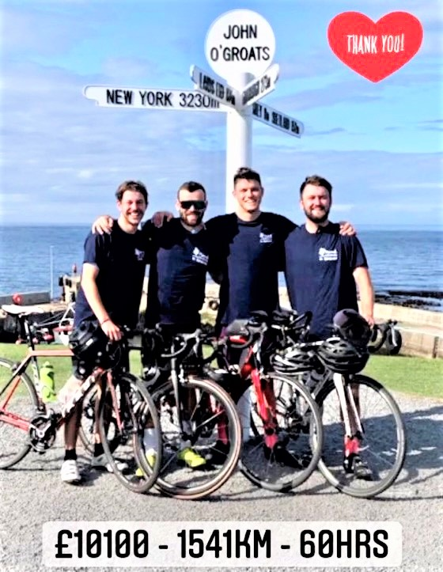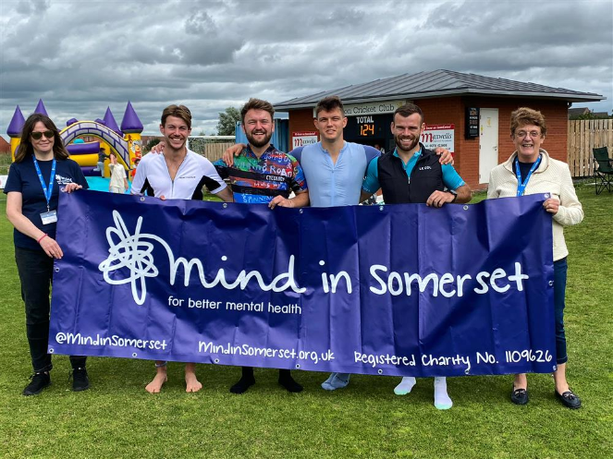

The four Old Queenians (Ed Shawcross, Arthur Banks, Will More, George Shepherd) cycled the 957 miles from Land’s End to John O’Groats with the challenge to raise £10,000 for mental health charity Mind in Somerset. In the event, they completed the challenge successfully raising a total of £11,400!

Huge congratulations to them on a job very well done!
AUGUST 2021.

