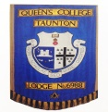
Queen’s College Taunton Lodge 6988
2016 REVIEW

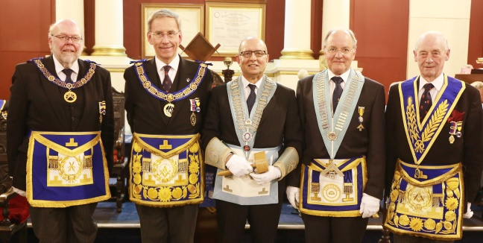
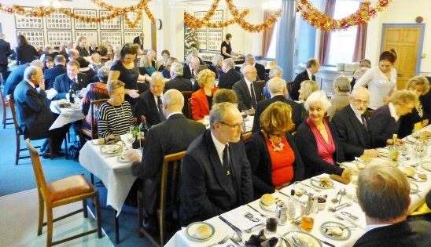
2015 ended with the regular Christmas lunch (left) at which a magnificent £1200 was raised (without match funding!) for the charity 2 Wish Upon a Star. Rhian Burke, who taught at Queens and set up the charity in 2012 following the deaths of her son George and husband Paul (an OQ), recently received the 2016 Just Giving Award for Outstanding Commitment. A great achievement for Rhian and a great pleasure for us to have been able to support her.

On Saturday 19th March, under the watchful eyes of the RW Provincial Grand Master, Stuart Hadler, the VW Deputy Provincial Grand Master, John Winston and RW Past Provincial Grand Master, Stanley Hopkins, W Bro Phil Jubb installed his successor, Bro Jim Virjee. In an impeccable delivery of the ‘Extended Working’, adopted by Queen’s College Lodge at its consecration 66 years ago, the whole ceremony enthralled those who had not seen it before (and also hopefully those who had!).
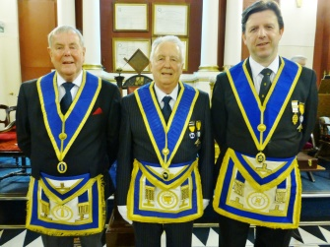
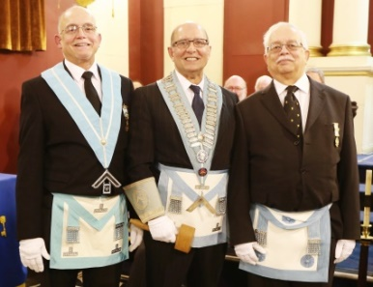
The occasion was made that bit more special for Jim when his brothers, W Bro Roy and Bro Zal (left) presented to him the First and Second Degree Working Tools. WM Jim said it was the first time in his life that his brothers had saluted him! His son, Daniel, who is a member of Dolphin Lodge, Bristol, had long ago booked a holiday which unfortunately coincided with the meeting. £500 was raised for charity.

A few days later at the Provincial Annual Meeting, W Bro Jonathan Dolling was appointed PPAGDC and W Bros Geoff Perrin and Nigel Chambers received promotions to PPJGW and PPGReg respectively (right). Very many congratulations to them all. It was great to see the Lodge so well represented in the Provincial honours list. 17 brethren from Queens and other Lodges retired to the Lamb in Axbridge for an excellent lunch organised by W Bro Mike Kinnersley.

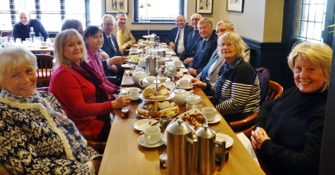
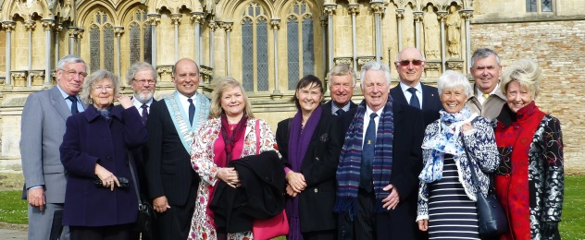
“Any excuse for a reunion” – In April, 14 Lodge members and wives travelled to Wells to support the Worshipful Master, Jim Virjee, and his wife, Debbie, at the Provincial Bi-Annual Service. Jim & Debbie launched themselves at the table of goodies laid on at a local hostelry (yet again organised by W Bro Mike Kinnersley who seems to know every pub within a very large radius of Chilcompton!) and the rest of us had no hesitation in following our leader’s example – after all, he is our ‘medical officer’ so if he says it’s OK, then it must be! With the Service starting at 5.30 pm on Sunday afternoon it gave ample chance to eat and talk before being ‘on parade’ in the Cathedral. Unfortunately, Ian and Brenda Gibson missed tea but joined everybody for the Service.
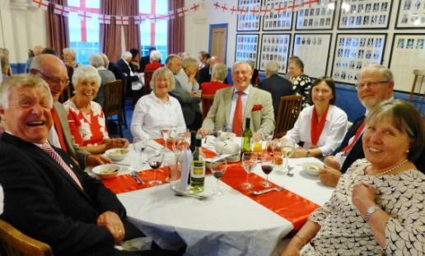
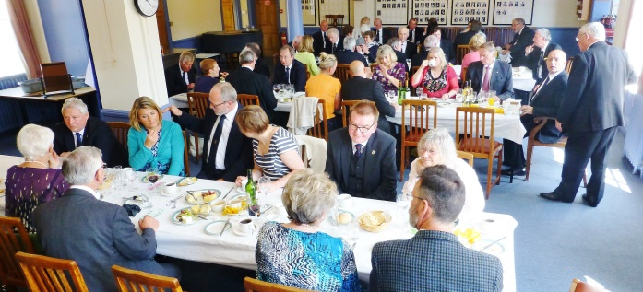
At the end of April, St George’s Day was celebrated at the Taunton Masonic Centre with 70 sitting down to a typically English dinner. This was followed by spontaneous recitations of Shakespeare Love Sonnets by conscripted ‘volunteers’ and the singing of various traditional English Songs. The Queens group (right) just couldn’t keep away and apart from those caught on camera Geoff & Sally Dolling, John & Lin Winston and Ivor & Gill Roberts were also there.

And yet more dining! Following the May meeting at which we received a most interesting talk by the Provincial Grand Orator, W Bro Rev Jeremy Hellier, entitled Masonry, Symbolism and Religion, 52 Brethren, ladies and guests enjoyed a summer lunch (left) and, suitably sustained, raised a further £700 for our charity, The Taunton Association for the Homeless.

In August, four Brethren (Kinnersley, Baker, Frewin and Rodgers) took a “busman’s” holiday to Stockholm with our wives. We were fortunate to visit the home of Swedish Freemasonry at Bååt’s Palace, the Masonic Temple owned by them for several centuries, where we were given a most informative guided tour. Later that evening the four Brethren attended a ceremony in ‘Johannessalen’, the main Masonic Hall.

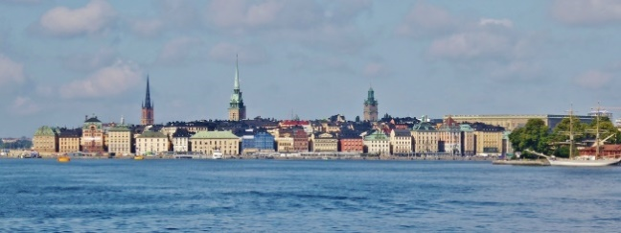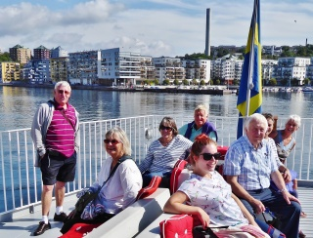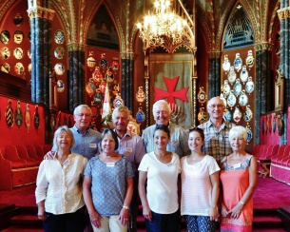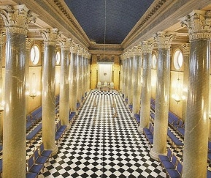

Unsurprisingly, the ceremony was in Swedish yet we all took an active part at times… the Tyler was not the only person to brandish a sword! We were warmly welcomed to the Festive Board at which a paperweight embodying a 3D image of Queen’s College was presented to the WM of Lodge St. Erik as a memento of the visit. The weather was kind to us and we had a super holiday exploring the city. Stockholm is a beautiful and vibrant city!

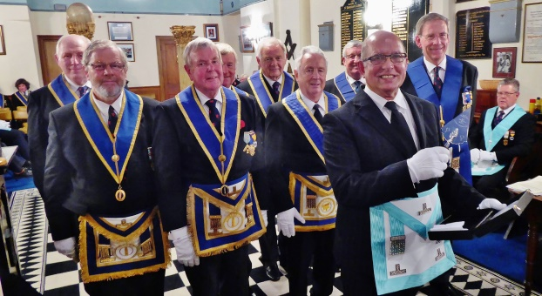
The Provincial Travelling Trowel continues its journey – and at our October meeting arrived at Queens. Royal Clarence Lodge 976, Bruton, presented the Trowel to Worshipful Master, Jim Virjee with Deputy PGM, VW Bro John Winston looking on (below left).
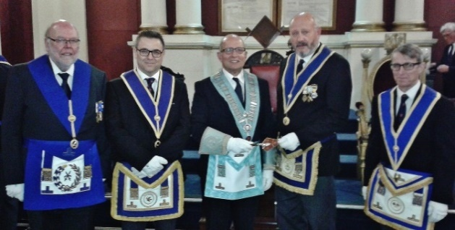
But we didn’t get to keep it for long before the WM, accompanied by 9 brethren including the PGM and Queens Honorary Member RW Bro Stuart Hadler, passed the Trowel on to St. Dunstan’s Lodge 7973, Glastonbury (above).

Plans for the October meeting received a set-back when the Candidate, Mr Malcolm Ness, was called away overseas on business. We were fortunate that W Bro Richard Conneely, brother of Secretary Ray, was able to step in at the last minute to give us a most interesting talk entitled “Where Is It Now”. The Festive Board raised a total of £340 for the Lodge Benevolent Fund. Malcolm is on a three-line whip to be with us in May 2017 to start his Masonic travels!

Unfortunately the news is not always good. During the year we bade farewell to Bro Martin Wallace-Jones (May) and W Bro Michael Fielding (November) both having succumbed to illness. Truly wonderful men who will be very sadly missed.

And finally......from the Worshipful Master....

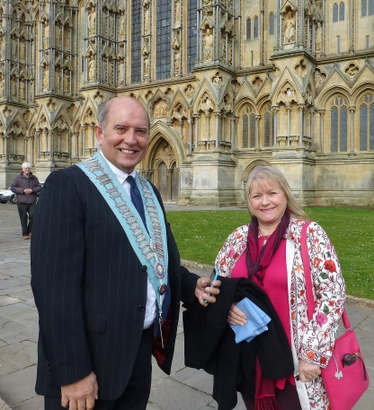
Brethren, I’ve had a terrific year (so far!!).
I have to say that it’s been an eye-opening experience for me to see just how much hard work and organising has to be done and I cannot thank enough a small caucus of members who, so unselfishly, do a really sterling job in ‘running the lodge’. They’ve willingly coaxed, reminded, helped and guided me so that I have been able to really enjoy the year.
I have been astounded by the generosity of our members and their guests - we have raised £1,200 so far for ‘Taunton Association for the Homeless’ and hope to more than double this (with the help of ‘match funding’ from the Province), for a cause that Debbie and I feel very strongly about. In addition, we’ve also raised enough to apply for our 4th Ashlar in consecutive years!
It was a joy to have our ladies join us again in May and I look forward to the Christmas lunch where we will be together again. They bring so much fun, colour, laughter and beautiful singing and I hope this trend will continue to include a resurrection of the ‘ladies’ night’.

Debbie and I wish you all a very happy Christmas and a successful 2017.
Jim Virjee

For regular news throughout the year please look at our Website: http://www.queenscollegelodge.co.uk/
Also Twitter: https://twitter.com/queens6988
And the Somerset Provincial Website: http://www.somersetfreemasons.org/

