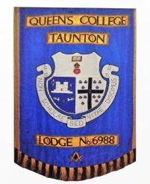 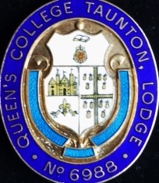 HURRIED NOTES AFTER INSTALLATION 16TH MARCH 2019

During his year in office, WBro Alan Watkins just over £3,000 was raised which he is seen below presenting to two local charities, £550 to ‘Yeovil Freewheelers’ (the ‘Blood Bikes’) at our popular Christmas meeting and £2,500 to S.U.R.E. (Somerset Unit for Radiotherapy Equipment) at the Beacon Centre, Musgrove on his last day as Worshipful Master! Receiving is Martin Surrey, Chair of the Freewheelers and Paul Alway, Chair of S.U.R.E. with Charity Steward, WBro Peter Thomas looking on.

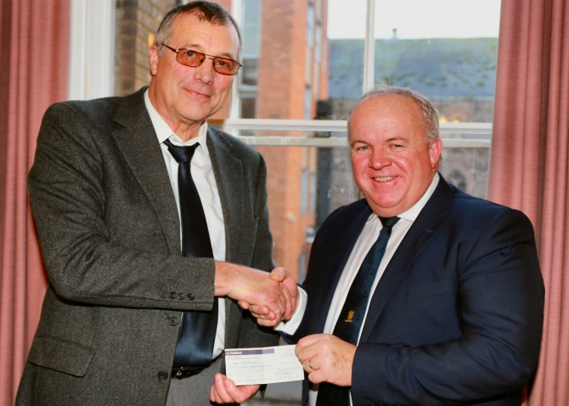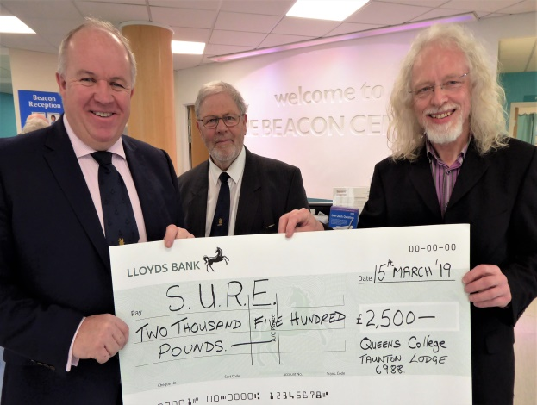

At Installation we were honoured by the presence of both PGM RW Bro Stuart Hadler and Deputy PGM VW Bro John Winston - the last to 6988 in their official capacities. WBro Peter Thomas for the late WBro Ivor Roberts after which Brethren stood to Order in respect to departed merit. An early task for the PGM was to present our lodge with our 5th Ashlar having raised £29,000 (against a target of £25,000) towards the Somerset 2020 Festival. WBro Jim Wiltshire (centre L), Charity Steward until 2018 stepped aside for personal reasons and WBro Peter Thomas, current Charity Steward continues Jim’s good work (R); Wm Alan looking on. 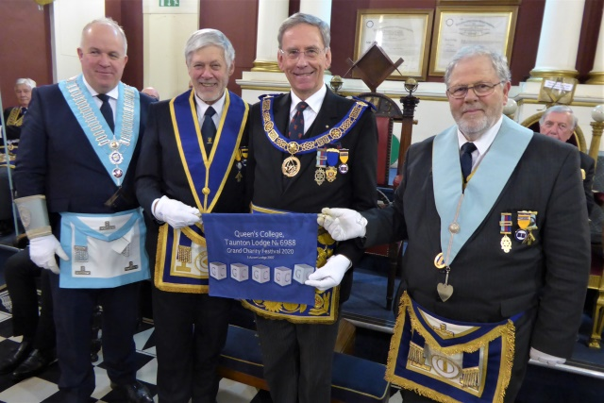

The Worshipful Master, Alan Watkins, installed his successor with the established ‘Queen’s Extended Ritual’ with the able assistance of his Officers and placed WBro Graham Ten Broeke (last Wm in 1998) in to the Chair in the presence of a full Temple. Acting Prov DC, George Sargeant PrAsstGDC, seated extreme (L) in vsiting for the first time, fulfilled his ambition to visit all 89 Craft lodges in the Province during his year.

WBro Graham seen being congratulated by WBro Alan at the conclusion of the ceremony, flanked by Wardens, (L), Senior Warden WBro Ray Conneely and R, WBro Lindsay Edmunds (R).
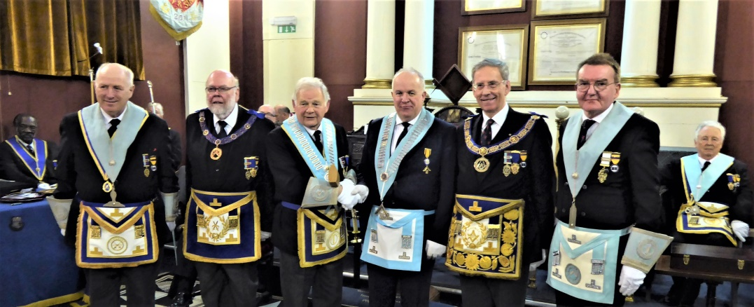

An excellent festive board followed when 75+ were seated in a packed dining room….. a remarkable sum of £1,150 was raised during the evening towards the Wm’s charity – CHSW, Wraxall.
