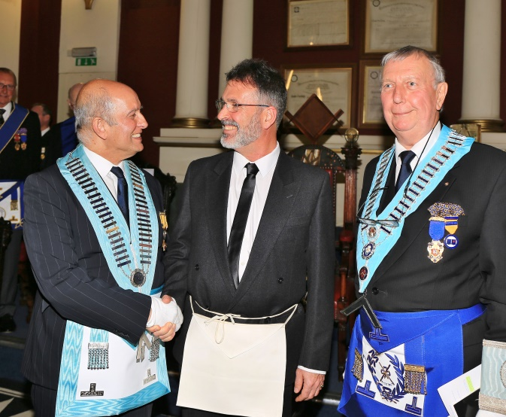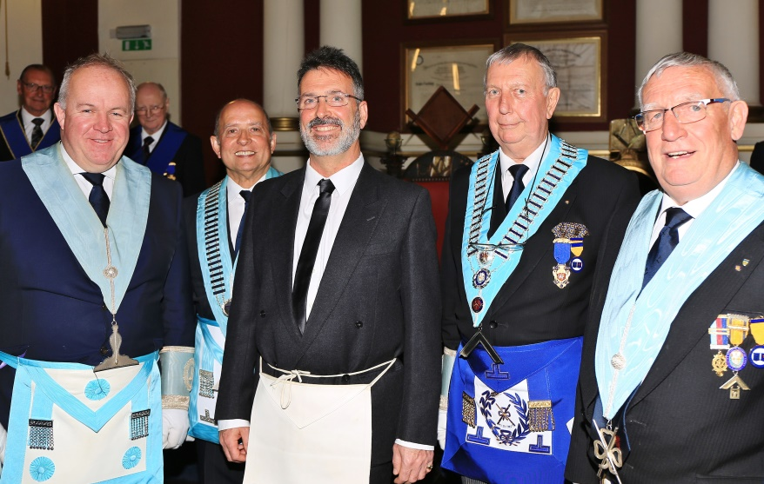

The Initiation of Malcolm Ness on 6th May 2017 - another unique Queen’s ceremony very well received by our 30+ guests. It was an evening when all those doing floor work distinguished themselves.

The Initiation ceremony was carried out by WBro Jim Virjee, IPM, seen congratulating Bro Malcolm with Wm Geoff Dolling looking on. Dates for Malcolm’s initiation last year had to be postponed so our current Worshipful Master very thoughtfully invited WBro Jim to conduct the ceremony which included a demonstration of the ‘Masonic Chain’, resuming the Chair to continue the remainder of the business.

The pictures include a group at the festive board and finally, looking very relaxed, Malcolm responding to his toast.

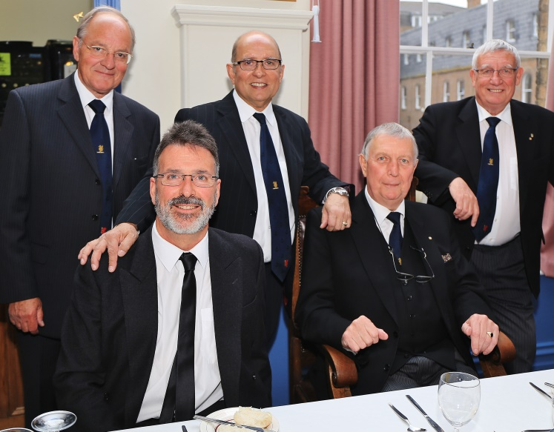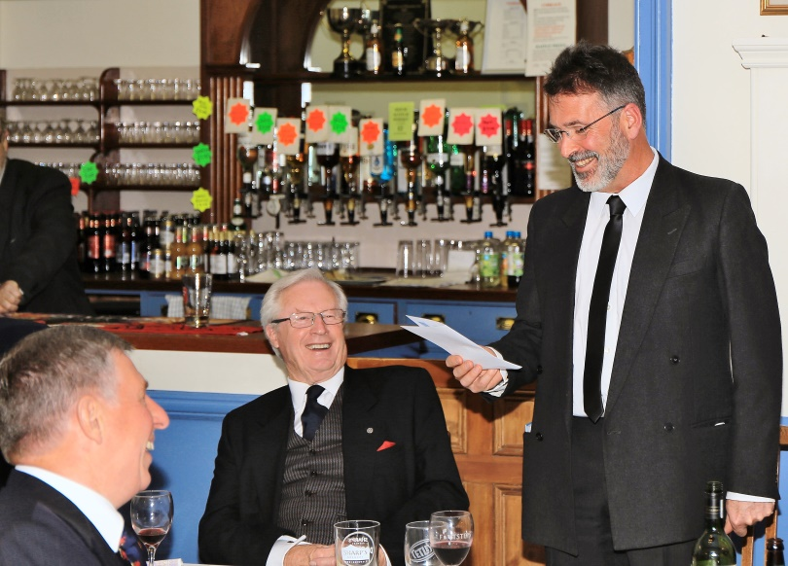

Richard Baker. LIO Queen’s 6988

