COPIED FROM SOMERSET PROVINCIAL WEBSITE…..

Provincial News April 2019

Annual Meeting of Provincial Grand Lodge
Over 700 Brethren attended the AGM at the Webbington Hotel on 4th April 2019 to Witness the Installation of W Bro David John Medlock as the new Provincial Grand Master of Somerset.
The RW Deputy Grand Master, Jonathan Spence conducted the Installation and after the Deputy Grand Secretary had read the Patent the New Provincial Grand Master was placed in the chair.
He then Installed his new Deputy Provincial Grand Master W Bro Benjamin G. W. Batley ( Ben) and then reappointed his two Assistant Provincial Grand Masters W Bro Barry L. T. McCormack and W Bro Martin C Slocombe. The New Provincial Grand Master then appointed and invested the Provincial Grand Officers for the ensuing year before awarding Past Provincial Grand Rank and promotions.
The RW Provincial Grand Master then addressed the brethren and received a rapturous applause; he urged everyone above all else to enjoy their Freemasonry and wished for a happy Province.
The agenda being complete the Provincial Grand Lodge was closed and the first verse of the National Anthem was sung. The RW Provincial Grand Master and the RW Deputy Grand Master retired in procession.
After a well earned break 450 Brethren reassembled for a well prepared lunch and with both the RW Deputy Grand Master and the RW Provincial Grand Master addressing the brethren the day closed with everyone having witnessed a very special event.

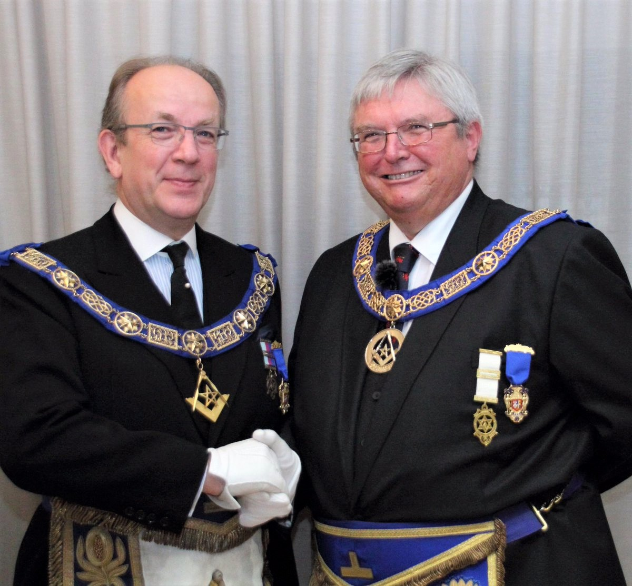
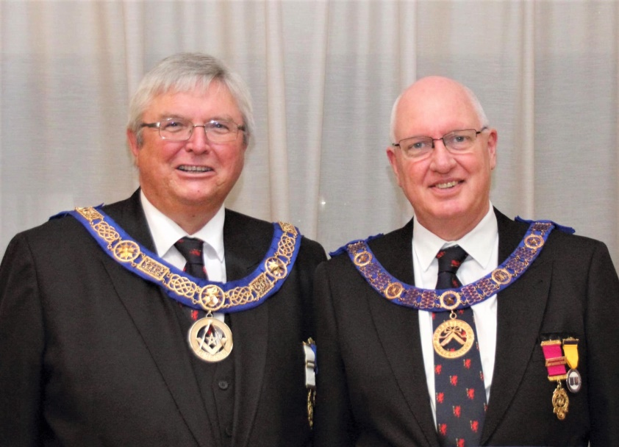Our new PGM with newly appointed DPGM Ben Batley
After the meeting, the Queen’s contingent hastened to The Lamb, Axbridge for refreshments kindly organised by WBro Mike Kinnersley.
