Brethren, you will all have received the minutes of 9th October of, what sounds to have been our very successful first regular lodge meeting since the start of ‘lock-down’ – since our Christmas December 2019 meeting, in fact! Unfortunately, I was unable to attend the meeting.

WBro Graham Ten Broeke remains Worshipful Master until our Installation Meeting in March next year; his chosen charity until then is ‘Taunton Riding for the Disabled’. Bro Richard Brown has at last been passed to a ‘Fellowcraft’ and WBro Jim Virjee excelled even his own high standards with his ‘Explanation of the Second Tracing Board’.

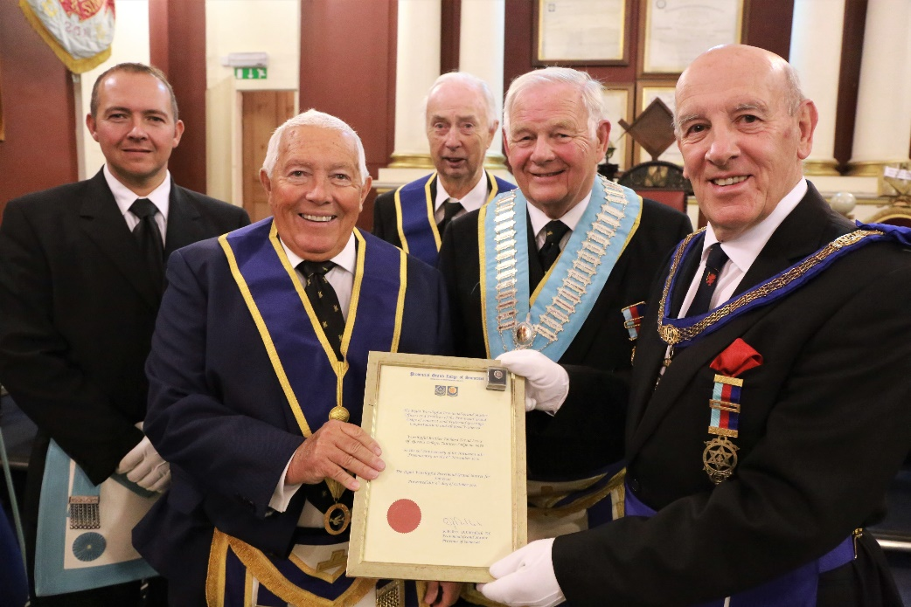
WBro Richard Lewis was initiated in to Queen’s College Lodge in November 1970, but was not WM until 2007. He was presented with his Somerset Provincial Grand Master’s Certificate commemorating his 50 years as a Freemason by WBro Martin Slocombe, APGM. WBro Richard was supported by his son, Bro Alex and also his life-long friend, WBro Brian Richards. (Photo: WBro Jim Wiltshire)

During the 1980s and 90s there was much speculation and ill-informed media attention focused on Masonry. No ‘shrinking violet’, when asked in 1997 to assist in a documentary TV programme on Masonic life from the Cardiff Lodge, entitled “Answering back”, WBro Richard spoke strongly in defence of Freemasonry, following which he was invited to join Edgar Rutter Lodge 7196, Cardiff, becoming WM in 2003; he was subsequently rewarded with a first Provincial Collar of PPrJGD (South Wales) in 2008.

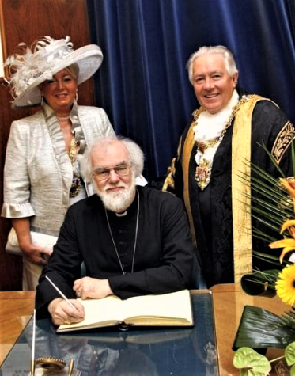
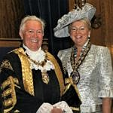
Running his own business in the centre of Swansea and with a great sense of public duty taking him in to local politics, he won a seat on Swansea City Council in 1973 on which he still serves having been on several committees. He served two years with the RAF and is still on their Civilian Committee. In 2010, he was honoured to become Lord Mayor of Swansea, with his wife Angela the Lady Mayoress. During this year he was instrumental in raising £90,000+ for Charity.
The then Archbishop of Canterbury, Rt Reverend Dr Rowan Williams, (previously Archbishop of Wales) signing the Visitors Book at the Mansion House, Swansea.
Report compiled by RB from info’ provided by Richard’s son Alex.
13.10.2021 Continued…
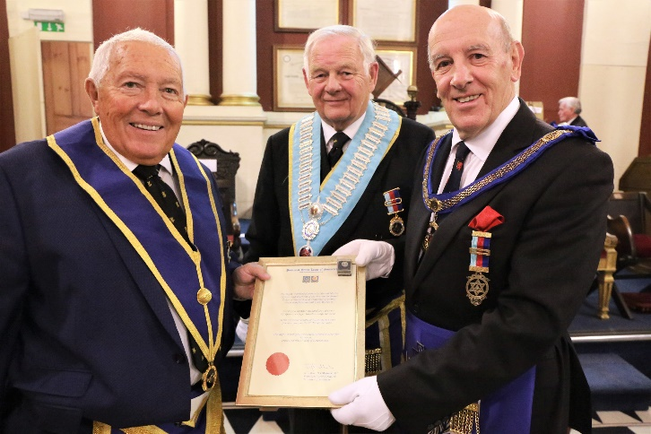
Page 1 was supposed to be ‘The End’ but more pictures have since come in from the Lewis family which you may find interesting.
The late Bro Martin Wallace-Jones (former OQ and 6988 member) was, presumably, an honoured guest at Richard’s inauguration when he was also supported by RAF cadets in which his daughter Francesca is front, far left. As a cadet she addressed us at Richard’s 2007 December meeting when we supported these cadets as his chosen charity.
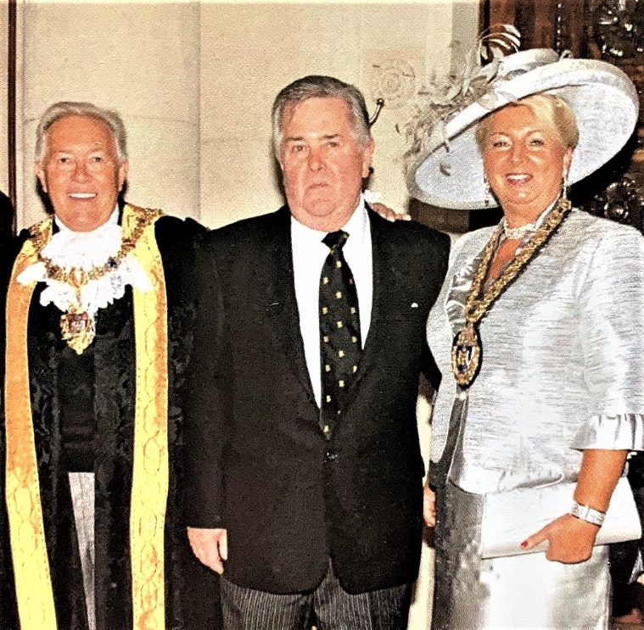
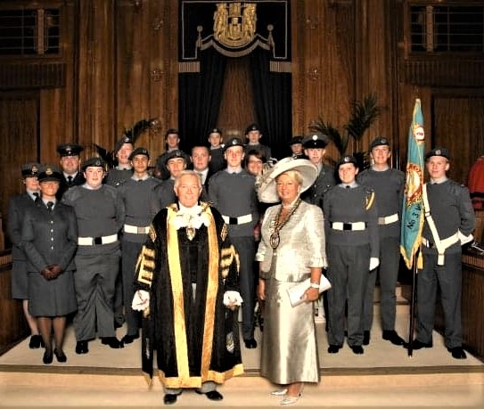

Further news; On Thursday 14th, Somerset Provincial AGM was held at the Webbington Hotel & Spa, near Axbridge when WBro Mike Rees was promoted to PPrGReg. By all accounts, it was a well planned meeting with brevity the order of the day. Nine Queen’s brethren met afterwards to enjoy an excellent lunch at an Axbridge pub, organized, once again, by Mike Kinnersley.
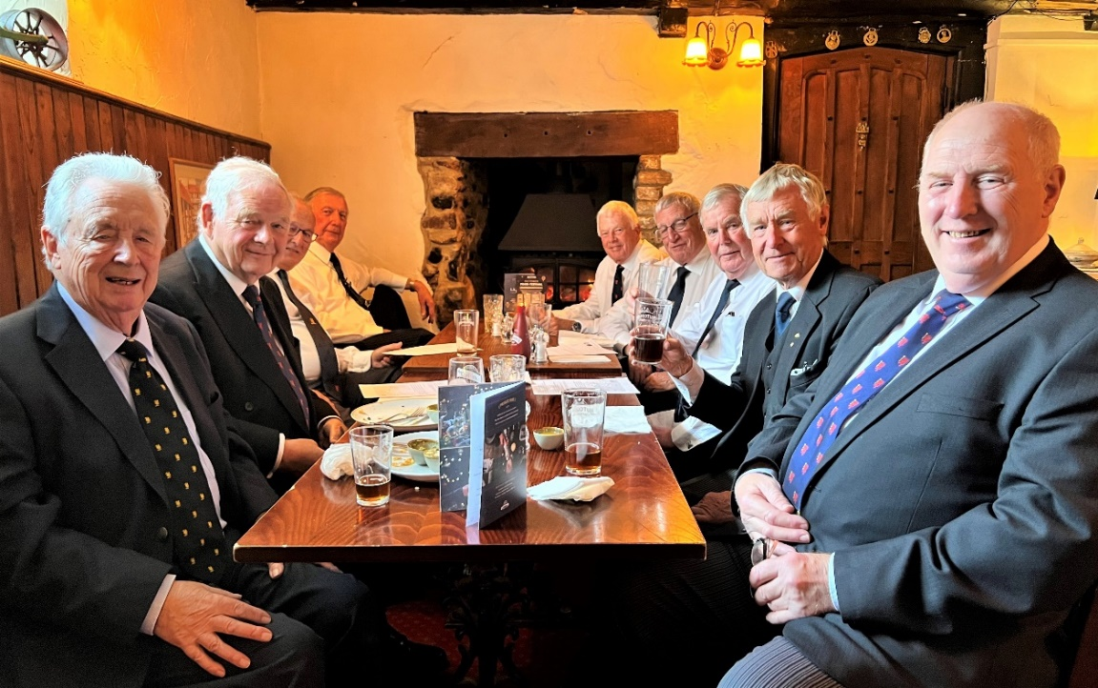
Thanks to WBro Ray Conneely for this picture.

NEXT SATURDAY, 23RD, we have the Federation of School Lodges AGM AT KINGSWOOD SCHOOL, BATH which only Mike Kinnersley and I seem to be attending from 6988?!

