QUEEN’S COLLEGE TAUNTON LODGE No.6988 PRESENTS £4,300 TO TAUNTON ASSOCIATION FOR THE HOMELESS AT COMMUNITY OPEN DAY….

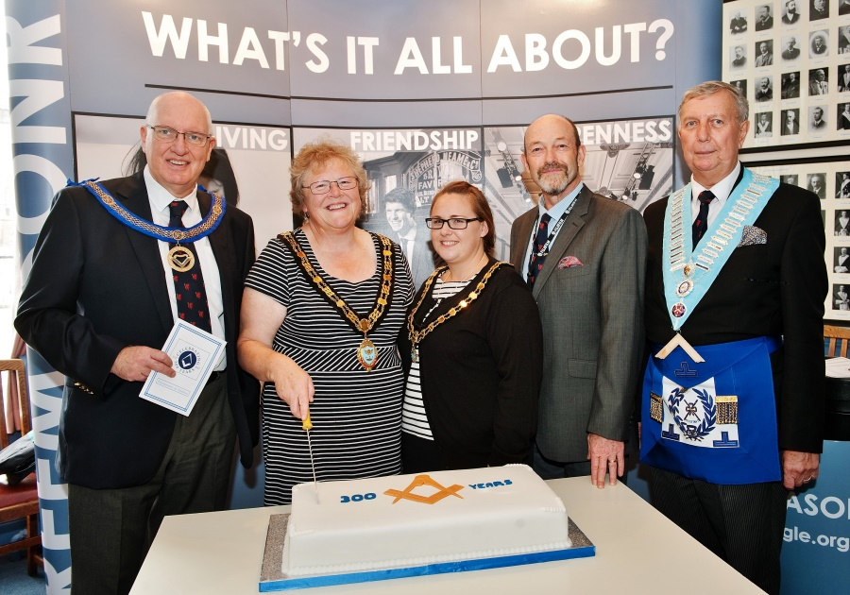
Saturday 30th September saw dozens of people attend Taunton Masonic Centre for a Community Open Day to celebrate the 300th Anniversary of the formation of the United Grand Lodge of England. To mark this historic occasion, the Mayor of Taunton Cllr. Hazell Prior-Sankey and her Consort attended. Her first duty was to cut a large cake especially baked for the occasion, watched over by APGM WBro Ben Batley; WBro Richard Parrish, Prov G Mentor and WBro Geoff Dolling, PAGDC, current Wm of Queen’s Lodge.
Later, in the Temple, Dr Jim Virjee of Queen’s College Taunton Lodge No. 6988 (Queen’s Lodge) presented £4,300 to Justin Roxburgh CEO of Taunton Association for the Homeless (TAH). £3,300 was raised by Queen’s Lodge and £1,000 was donated by the Province under ‘matched funding’. Dr Jim, as the previous Master of the Lodge, was instrumental in raising funds for this worthwhile cause. This is a charity which Queen’s College and the Lodge have supported previously. Recent Provincial internal figures covering the past 10 years suggest approximately £87,000 has been given to non-masonic charities by the 11 Masonic ‘Craft’ lodges in Taunton and Wellington, including 5 school lodges; Queen’s Lodge contributed 30%!
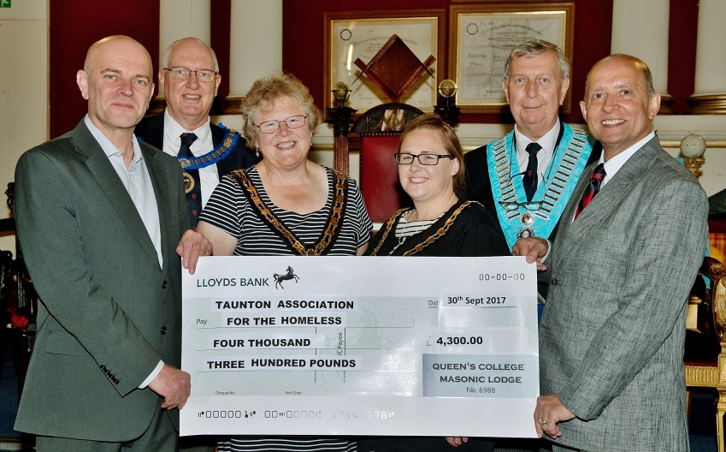
In the presentation photo – pictured left to right: Justin Roxburgh (CEO of TAH); Ben Batley (Assistant PGM); The Mayor of Taunton Deane Cllr. Hazell Prior-Sankey, Joanna Hallett (Mayor’s consort), Geoffrey Dolling (Current Wm of Queen’s Lodge) and Dr. Jim Virjee (IPM Queen’s Lodge).
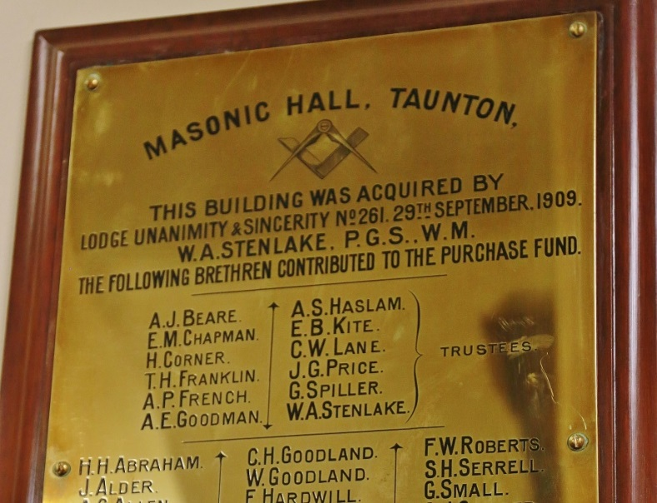
After nearly 50 years having their regular meetings at the School, Queen’s Lodge was required in 2002 to transfer to other premises finally settling at Taunton Masonic Centre in 2004. It is interesting to see a plaque commemorating the purchase of the Masonic Centre which records Arthur Haslam, a former Headmaster of Queen’s College (a Methodist Foundation) and member of Lodge 261 as one of the original Trustees having also contributed to its purchase.
Why interesting? Because the building was bought on 29th September 1909 while QCT Lodge 6988 was not formed until 1950!

