Queen’s College Lodge’s Longstanding Support Of Children’s Hospice South West.
At long last, and grateful for the support of WBros Jim Wiltshire, Mike Kinnersley and Dr Jim Virjee, the picture shows the Worshipful Master of Queen’s College, Taunton Masonic Lodge, Graham Ten Broeke, presenting £2,782 to Julie, Area Fund Raiser for Children’s Hospice South West. Charlton House, Wraxall, was chosen by Graham and the sum was raised during his year as Master 2019. Covid frustrated previous presentation attempts. Happily, this now also coincides with the 30th Anniversary of the Charity.
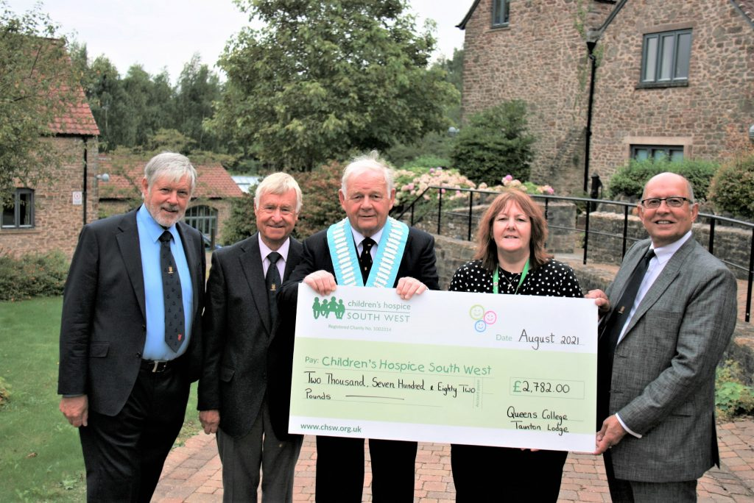
Situated in Wraxall, North Somerset, on the outskirts of Bristol, Charlton Farm usually cares for children and families who live in South Gloucestershire, Bath and North East Somerset, West Wiltshire, Bristol City and North Somerset. “Charlton Farm is a place of love, happiness and friendship. We hope to provide a haven, a place where children and their families can be nurtured and cosseted, returning home with renewed vigour and a sense of anticipation for the next visit.”
Children’s Hospice South West provides hospice care for children and families who live in the South West and delivers this service from three children’s hospices across the region, known as ‘Precious Lives across SW’ – at Barnstaple, St Austell and Bristol. They care for children and young people, aged 0-21 from the point of diagnosis, who have a life-limiting or life-threatening condition and are not expected to survive into adulthood, as well as providing support to their families. The Care Teams at the hospices create a relaxed, informal but very supportive atmosphere.
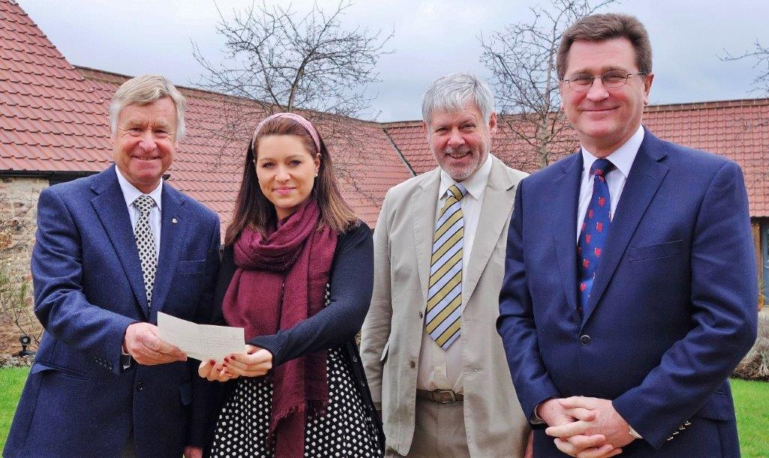
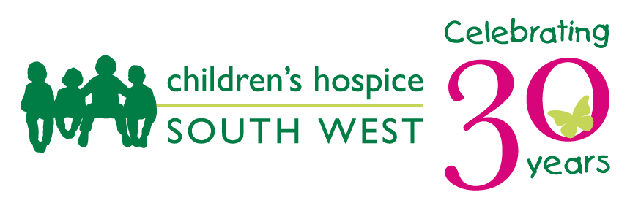
WBro Mike Kinnersley also chose to support Charlton Farm during his year as Master in 2014, presenting £2150.
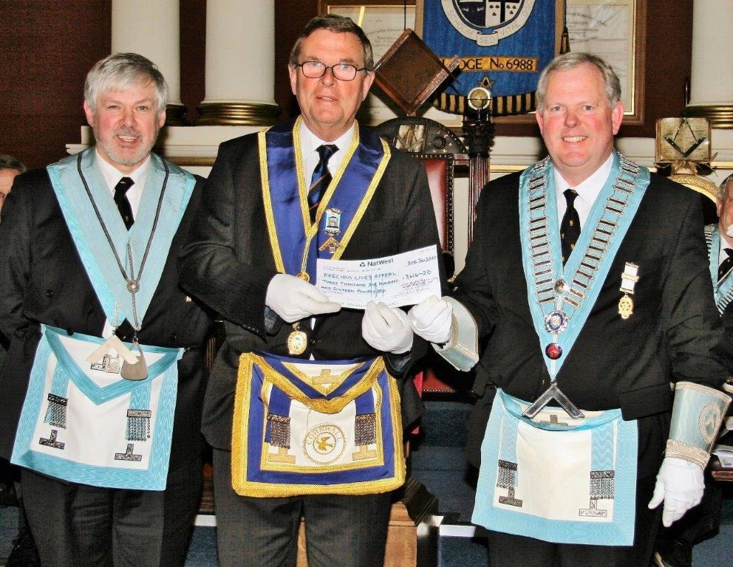

WBro Robert Francis answered the ‘Precious Lives Appeal’ in 2010, presenting over £3,600 to ‘Little Harbour’, St Austell, (the newest of the CHSW group) helping them achieve their ‘launch target’ in 2011.

